Noninvasive ventilation
Antoine Cuvelier
Pulmonary and Intensive Care Department, Rouen University Hospital & UPRES EA 3830 (IFR MP23), Institute for Biomedical Research, University of Rouen, France

Concept
Noninvasive ventilation (NIV) is a modality of mechanical ventilation where the patient is connected to the ventilator via a nasal mask, a facial mask or a mouth piece. NIV exclude a direct tracheal connection like in intubated or tracheotomised patients (invasive ventilation).
NIV is one of the treatment of chronic respiratory failure (CRF) and also acute respiratory failure either purely hypoxemic (ARF) or hypoxemic and hypercapnic (AHRF). Ventilation is delivered through a positive pressure ventilator and its major objective is to improve alveolar hypoventilation and subsequent arterial blood gases, especially PaCO2. NIV should be distinguished from continuous positive airway pressure (CPAP) which is a validated treatment for obstructive sleep apnea syndrome. CPAP is not a ventilatory technique since it does not modify the alveolar ventilation and does not reduce PaCO2 in hypercapnic patients.

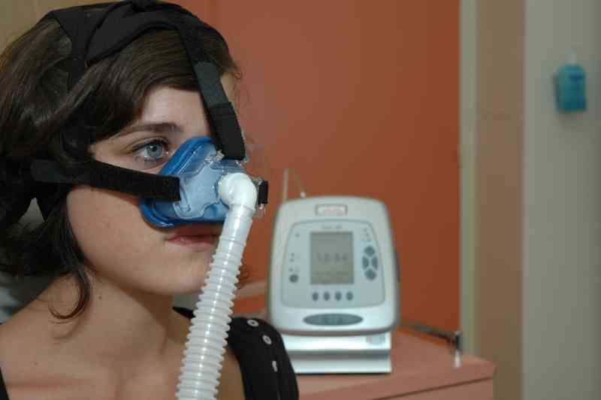
Figure 1: The concept of noninvasive ventilation (NIV).

History
First attempts to ventilate via a face mask have been performed in the second half of the 20th century but mostly with devices that delivered pressure peaks (IPPB intermittent positive pressure breathing) and not with devices that effectively ventilated the patients. The French chest physician Paul Sadoul was one of the very first to perceive the deleterious impact of tracheal interfaces for mechanical ventilation and worked to find a substitute through an anesthesia face mask and an ICU ventilator. The first clinical results in 11 patients with chronic obstructive pulmonary disease (COPD) and AHRF were presented in a scientific meeting in 1964 in Nancy, more than 25 years before the publication of the first randomized controlled study. As this time, the investigators already stated a 70 % success rate of the treatment, claimed the importance of the expertise of the medical and nursing staff to appropriately manage these patients and had identified the difficulties to set the ventilator and the deleterious consequences of leaks around the facial masks. In 1989, Meduri in USA, suggested to use NIV during ARF of other etiologies than COPD.
In patients with CRF, the development of NIV was more recent because of a lack of adequate ventilators and interfaces for a long-term utilization. As soon as 1983, Yves Rideau in Poitiers suggested that nocturnal ventilation through the nose was possible on a long-term basis in patients suffering from Duchenne myopathy. The identification of the sleep apnea syndrome in Australia in 1981, the development of CPAP masks in order to treat this disease and the development of volumetric ventilators has favored the management of CRF at home. Through dynamic chest physicians in Amiens and in Lyon, an associative network in France was the first in the world and to formalize the concept of domiciliary ventilation. It is now considered as a model throughout the Western world (1).
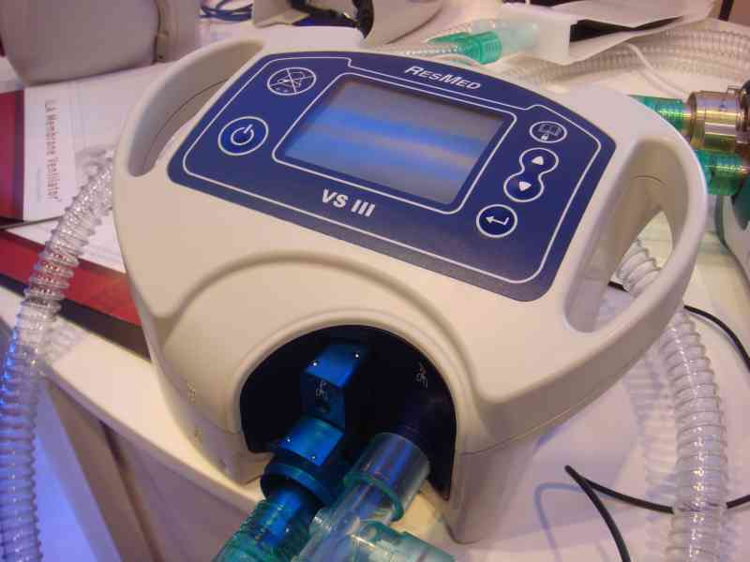
Figure 2: An example of available ventilator for domiciliary NIV.

At the end of the 90’s, the French chest physicians began to treat their respiratory failure patients in dedicated units called intermediate care units. Only recently, the intensive care units (ICU) have progressively adopted the main NIV techniques in order to reduce the intubation rates in some specific acute disorders. A major delay is still identified in 2009 in a majority of US and Australian ICUs and Emergency Care Units.

A clinical evaluation of NIV
NIV in the chronic settings
The clinical efficacy and the benefits of long-term NIV in patients with CRF due to restrictive pulmonary diseases (scoliosis, tuberculosis sequellae, neuromuscular diseases), have been stated in 1994 and 1995 (2) in order to replace tracheotomy-mediated domiciliary ventilation. Even if these studies were non-randomized and non-controlled, their positive results would make any future randomized studies unethical.
During sleep, NIV improves arterial blood gases (hypoxemia and hypercapnia), improves the quality of sleep and the effects are still remnant during the following day with improvement of diurnal quality of life and diurnal blood gases. In patients with COPD and CRF, three controlled-randomized studies did not find any benefit of domiciliary NIV when performed in association with long-term oxygen therapy (3). However, most studies have found that the ventilated COPD patients had less exacerbations of their disease and were less hospitalized for acute respiratory failure.

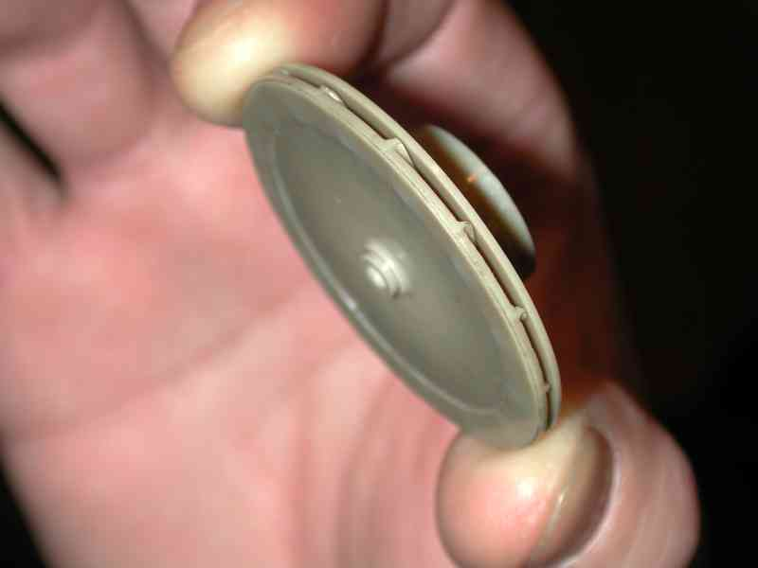
Figure 3: Most NIV domiciliary ventilators are delivering airflow through a high performance turbine that works until 40 to 60 000 turns per minute.

NIV in the acute settings
Acute hypercapnic respiratory failure in COPD is a major issue in this disease and is one of its main related causes of death. The NIV benefits in this situation have been evaluated by more than fifteen controlled-randomized studies and a least three meta-analyses (4). As compared with the standard management (oxygen therapy and pharmacological treatment), NIV allows a 60 % reduction of endotracheal intubations (one intubation avoided in four patients treated by NIV) and a more rapid improvement of the clinical status of the patients. Moreover, NIV is associated with a 50 % decrease of mortality rate (one death avoided for 10 treated patients), a decrease of hospital and ICU lengths of stay in hospital and a decrease in the number of hospital-acquired infections. It is likely that NIV reduces the health costs associated with these patients.
A high level of evidence is now available to assert the efficacy of NIV to manage hypercapnic acute pulmonary edema and the ventilation can be initiated as soon as the Emergency Unit if its team is trained to the technique. Another situation is acute hypercapnia and respiratory acidosis in obese patients. The epidemics of obesity and their pulmonary-related complications has favored the development of NIV in these patients were regularly (and difficultly) intubated, still a few years ago. The clinical benefits of NIV are much more debatable in the absence of hypercapnia, for instance during pneumonia with hypoxemic acute respiratory failure.

Daily practice of NIV
NIV is not an easy technique to manipulate. The environment to perform this type of mechanical ventilation should be adapted and the medical and nursing staff should have acquired competence to manipulate the ventilator, the interfaces and to regularly adapt these to the evolving clinical situations. The education of the staff should be regularly renewed. Written protocols should be available and the staff should be trained to manipulate the ventilators not only at bedside but also during educative bench-tests.
The choice and the management skill of the NIV interfaces are probably essential for the tolerance and the efficacy of the treatment. All models of nasal, facial and other types of masks should be available in different sizes. Also, the humidification of the airways should be taken into account in order to avoid important complications that may alter the clinical results of the treatment.
An efficient clinical monitoring is necessary to get the maximal clinical benefits and an acceptable compliance to the NIV treatment, either in patients with acute or chronic respiratory failure. This monitoring includes respiratory rate (under ventilation but mostly spontaneous), heart rate and transcutaneous oxymetry. Iterative arterial blood gases should be drawn regularly (5). Moreover, the expiratory tidal volumes and the presence of leaks should be regularly assessed. The occurrence of patient-ventilator dyssynchronies should be also regularly checked.
During chronic respiratory failure, NIV initiation is at best performed in chronic ventilatory units, in order to optimize the ventilator settings and the interfaces before discharging home with the material (6). A regular monitoring in these specialized units is progressively developing since a correct compliance to the treatment (an average of 5-8h per night, according to the clinical situations) is obligatory for the success. In France, all patients with domiciliary ventilation are regularly monitored every 3-12 months according to the underlying severity of the disease (7). Finally, the excellence of the provider who is in charge of the patient in his domiciliary environment is another key issue for a long-term management of the patient.

The future of the concept
NIV is a technique that will still develop in the next years. NIV is under-utilized by some ICU teams and the prevalence of the concerned patients is continuously increasing. Indeed, COPD is a very frequent disease that will become the third cause of death in 2020. But also the prevalence of patients with chronic cardiac failure, of patients with pulmonary-related complications of obesity or even patients with neuromuscular diseases in adulthood is still increasing. New indications of NIV are now evaluated in the post-surgical care and also in the management of patients with end-stage lung diseases, in order to improve breathing comfort when invasive ventilation is considered as unethical or is refused by the patient.
The NIV development will be favored by new technological improvements, allowing collecting ventilatory parameters in real time or after one to several nights under ventilation. A domiciliary ventilator interfaced with a transcutaneous capnograph permit to record the variations of arterial PCO2 during several consecutive hours, for instance during sleep. Also, polysomnography allows to monitor the ventilatory cycles breath-per-breath and to evaluate the clinical impact of these variable breaths on the quality of sleep and nocturnal oxygenation.
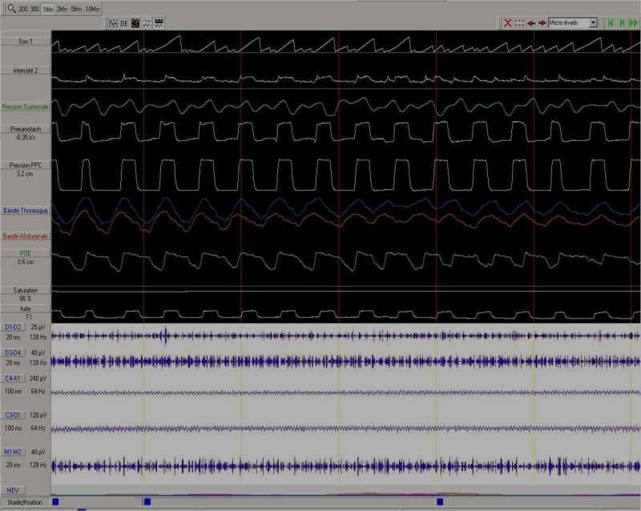
Figure 4: Polysomnographic monitoring under domiciliary NIV.

At the present time, a few clinical researchers are trying to evaluate the clinical impact of patient-ventilator dyssynchronies and are now searching the best way to improve them. This is the direction we have taken in collaboration with Christophe Letellier and his team in Rouen (8-9). It may lead to auto-regulated ventilators that automatically adjust their functioning to the patient’s needs and tolerance. We will develop this aspect in the final part of our talk.

References
1. Stuart M, Weinrich M. Integrated health system for chronic disease management: lessons learned from France. Chest 2004;125:695-703.
2. Orlikowski D, Prigent H, Gonzalez J, Sharshar T, Raphael JC. Ventilation mécanique à domicile et au long cours des patients neuromusculaires. Rev Mal Respir 2005; 22:1021-30.
3. Cuvelier A, Molano LC, Muir JF. Ventilation a domicile chez les patients atteints de bronchopneumopathie chronique obstructive (BPCO). Rev Mal Respir 2005; 22:615-33.
4. Keenan SP, Sinuff T, Cook DJ, Hill NS. Which patients with acute exacerbation of chronic obstructive pulmonary disease benefit from noninvasive positive-pressure ventilation? A systematic review of the literature. Ann Intern Med 2003; 138:861-70.
5. Clinical guidelines from SPLF-SRLF-SFAR. Noninvasive ventilation during acute respiratory failure (newborn excepted). Paris, October 12, 2006. Available on www.splf.org.
6. Muir JF, Cuvelier A. How to set up a chronic ventilator service. In: Principles and practice of non-invasive ventilation and weaning. Mark Elliott M, Nava S, Schönhofer B Eds. Hodder Arnold. London. In Press.
7. Haute Autorité de Santé. Practical aspects of long-term noninvasive positive pressure ventilation at home in neuromuscular disease. Clinical practice guidelines. 2006. www.has-sante.fr/portail/jcms/c_334439. Last access July 22, 2009.
8. Achour L, Letellier C, Cuvelier A, Verin E, Muir JF. Asynchrony and cyclic variability in pressure support noninvasive ventilation. Comput Biol Med 2007;37:1308-1320.
9. Rabarimanantsoa H, Achour L, Letellier C, Cuvelier A, Muir JF. Recurrence plots and Shannon entropy for a dynamical analysis of asynchronisms in noninvasive mechanical ventilation. Chaos 2007;17:013115.

